**Complete the figure to make it axially symmetrical. The red line is the axis of symmetry. Objective: Pupils learn how to find the axially symmetric. Draw it.**

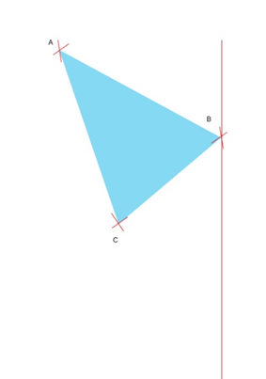chatGPT4  
To complete the figure and make it axially symmetrical with respect to the red vertical line (which is the axis of symmetry), follow these steps:

1. **Reflect each vertex (A, B, and C):** The points of the triangle need to be mirrored across the red vertical line. For this:
   * Measure the perpendicular distance from point A to the red line, then mark a point on the opposite side of the red line at the same distance.
   * Do the same for point B, which is already on the red line. Its reflection will be on the same line, directly opposite.
   * Finally, mirror point C similarly by measuring the perpendicular distance to the red line and placing a new point on the opposite side.
2. **Connect the new points:** After reflecting all three vertices (A', B', and C'), connect them with straight lines to form the symmetrical triangle.

In summary:

* The original triangle's reflection will mirror its shape across the red line, creating a symmetrical figure.

If you want, I can create an image for you that shows this reflected shape. Would you like me to do that?

**Complete the figure to make it axially symmetrical. The red line is the axis of symmetry. Objective: Pupils learn how to find the axially symmetric.**



ChatGPT4

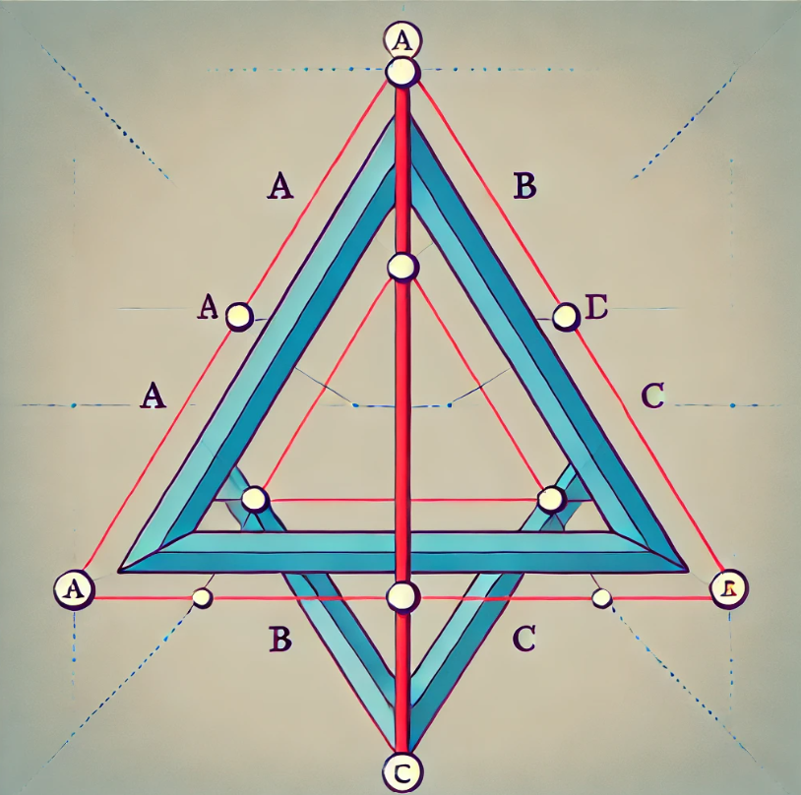

Here is the completed figure showing the axial symmetry of the triangle across the red vertical line. The original triangle on the left is mirrored onto the right side, demonstrating symmetry. This can help pupils learn how to find the axially symmetrical figure by reflecting points across the axis.

**Complete the figure to make it axially symmetrical. The red line is the axis of symmetry. If we know that we can find axial symmetry by drawing the triangle equal on its sides. How would you complete the figure? Draw it.**



ChatGPT4

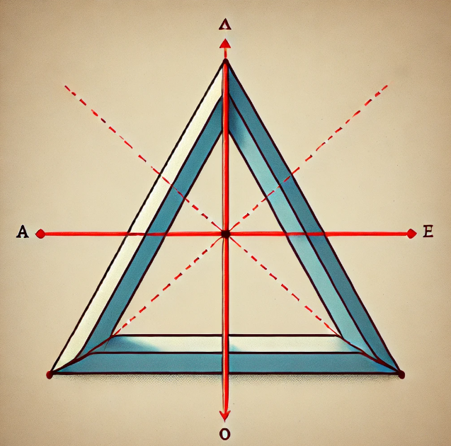

Here is the completed figure showing axial symmetry across the red vertical line. The triangle on the left side is reflected onto the right side, maintaining equal sides and angles. This demonstrates how axial symmetry can be achieved by ensuring both triangles are identical in shape and size.

**Complete the figure to make it axially symmetrical. The red line is the axis of symmetry. What you see here is the red line, which is the axis of symmetry. To find an axial symmetry, you need to draw the triangle equal on its sides on the axis. How would you solve this? Draw it.**



chatGPT4

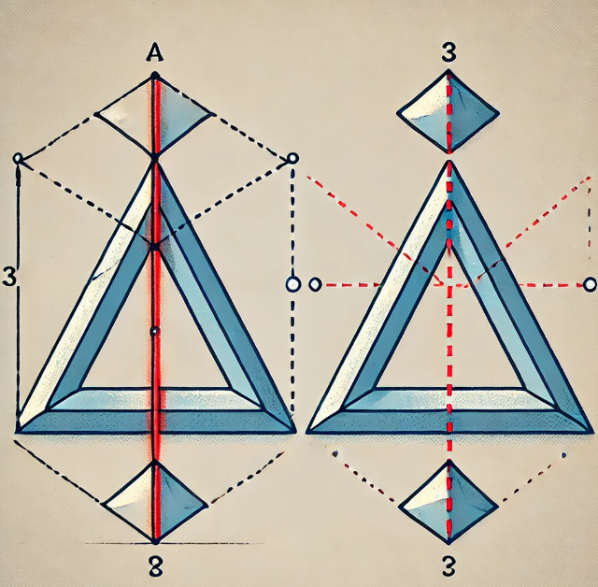

Here is the completed figure showing how to make the triangle axially symmetrical along the red vertical line. The triangle on the right mirrors the one on the left, ensuring that both triangles have equal sides and angles, aligned perfectly along the axis of symmetry. This illustrates the concept of finding axial symmetry by drawing an equal triangle on the opposite side.

**Complete the figure to make it axially symmetrical. The red line is the axis of symmetry. Please solve this step by step.**

chatGPT4

To complete the figure and make it axially symmetrical about the red vertical line (axis of symmetry), follow these step-by-step instructions:

### **Step 1: Understand the Axis of Symmetry**

* The red line acts as the axis of symmetry. This means that any point on the left side of the red line will have a corresponding point on the right side, exactly mirrored across the red line.

### **Step 2: Identify the Vertices of the Triangle**

* Let’s call the three vertices of the triangle AAA, BBB, and CCC, with all points being on the left side of the axis.

### **Step 3: Measure the Distance of Each Vertex from the Axis**

* For each vertex AAA, BBB, and CCC, measure the perpendicular distance from that point to the red line (axis of symmetry). The perpendicular distance means drawing a straight line from the point to the axis, forming a right angle (90 degrees) with the axis.

### **Step 4: Plot the Reflected Points**

* After measuring the distance of each vertex, plot the reflected points A′A'A′, B′B'B′, and C′C'C′ on the other side of the red line. Each reflected point must be the same distance from the axis as the original point but in the opposite direction.
  + If point AAA is 2 cm away from the axis on the left side, place point A′A'A′ 2 cm away from the axis on the right side.

### **Step 5: Connect the Reflected Points**

* After plotting points A′A'A′, B′B'B′, and C′C'C′, connect them using straight lines. The result will be a triangle on the right side of the axis, which is a mirror image of the original triangle on the left side.

### **Step 6: Final Check**

* Ensure that both triangles are perfectly symmetrical along the red axis. This means:
  + The length of sides in the original triangle matches the corresponding sides in the reflected triangle.
  + The angles of the reflected triangle are the same as the angles of the original triangle.

By following these steps, you will complete the figure, making it axially symmetrical along the red line.

If you'd like, I can provide another visual representation of these steps. Let me know!